H.T No
Regulations:
A18

Sreenidhi Institute of Science and Technology
(An Autonomous Institution)
Code No: 7HC13 Date: 24-Jan-2025 (FN)

B.Tech II-Year I- Semester External Examination, January - 2025 (Supplementary)
TRANSFORM TECHNIQUES AND NUMERICAL METHODS (EEE and ECE)

Time: 3 Hours Max.Marks:70

Note: a) No additional answer sheets will be provided.
b) All sub-parts of a question must be answered at one place only, otherwise it will not be valued.
c) Missing data can be assumed suitably.

Bloom's Cognitive Levels of Learning (BCLL)

Remember | L1 | Apply | L3 | Evaluate | L5
Understand | L2 | Analyze | L4 | Create | L6

Part - A Max.Marks:20
Answer all QUESTIONS

 |  | BCLL | CO(s) | Marks
1 | Find 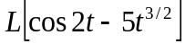 | L2 | CO1 | [2M]
2 | Evaluate Z(na^{n} ) | L1 | CO2 | [2M]
3 | Classify the PDE 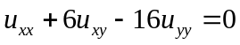 | L1 | CO3 | [2M]
4 | Write the Newton’s iterative formula to find. | L2 | CO4 | [2M]
5 | Find 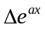with h=1 | L2 | CO5 | [2M]
6 | Write Runge-Kutta second and fourth order formulae. | L1 | CO6 | [2M]
7 | Find 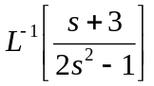 | L2 | CO1 | [2M]
8 | Solve 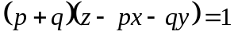 | L1 | CO3 | [2M]
9 | Write the formula for Runge-kutta method of fourth order. | L1 | CO5 | [2M]
10 | Explain Bisection method in finding the roots of equation. | L2 | CO4 | [2M]
Part – B Max.Marks:50
ANSWER ANY FIVE QUESTIONS. EACH QUESTION CARRIES 10 MARKS.

 |  |  | BCLL | CO(s) | Marks
11. | a) | Evaluate 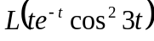 | L3 | CO1 | [5M]
 | b) | Using Convolution theorem, evaluate 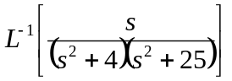 | L3 | CO1 | [5M]
12. |  | 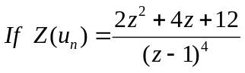 then find 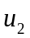 and 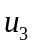 | L4 | CO2 | [10M]
13. | a) | Solve x (y – z ) p + y (z –x ) q = z (x-y). | L3 | CO3 | [5M]
 | b) | Solve 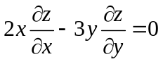 | L3 | CO3 | [5M]
14. | a) | Find the positive real root of the equation 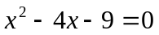by using Newton Raphson method. | L3 | CO4 | [5M]
 | b) | Using Simpson’s 1/3rd rule, find the value of the integral 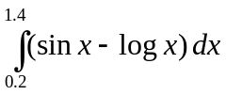by taking 6 sub-intervals. | L3 | CO4 | [5M]
15. | a) | Determine the interpolating polynomial f(x) from the following table using Newton’s forward formula. | L3 | CO5 | [5M]
  x | 0 | 1 | 2 | 3
  f(x) | 4 | 3 | 24 | 39
 | b) | Evaluate the value of f(42) from the following data using Gauss formula. | L3 | CO5 | [5M]
  x | 20 | 25 | 30 | 35 | 40
  f(x) | 354 | 332 | 291 | 260 | 231
16. |  | Using R-K method, estimate y(0.2) and y(0.4) for the equation 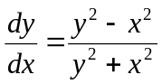 y(0)=1 with h=0.2. | L3 | CO6 | [10M]
17. | a) | Find 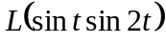 | L3 | CO1 | [4M]
 | b) | Find 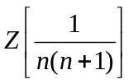 | L3 | CO2 | [3M]
 | c) | Form a PDE by the elimination of arbitrary constants from 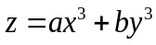 | L3 | CO3 | [3M]
18. | a) | Find the interpolating polynomial for the following data using Newton’s Backward interpolation formula. | L3 | CO5 | [5M]
  x | 1 | 2 | 3
  f(x) | 1 | 2 | 9
 | b) | Use picard’s method to approximate y when x=0.5. Given that y=1 when x=0 and 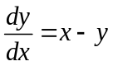 | L2 | CO6 | [5M]

-- 00 -- 00 –

